Story County
“Friends of the Fair”
Sponsor Registration
Please check the sponsor level you wish to donate at. Include your 1st year donation with this form. This will be a three (3) year commitment. Annual statements will be sent January 1st each year. Advertising artwork must be submitted to the fair office by June 1st, 2023. Artwork may be emailed to SCFair85@gmail.com or enclosed with this form.
Make your checks payable to: Story County Fair Association
P.O. Box 163
Nevada, IA 50201

_____ #1 Supreme Sponsor $2500.00+
Sponsor will receive a 24” x 36” vinyl sign. Sponsor will have the option to have their sign displayed at the fairgrounds during the duration of the commitment. Sponsor will receive public recognition during the fair. Sponsor will be listed in the Story County Fair website and social media.
____#2 Champion Sponsor $1500.00
Sponsor will receive a 16” x 24” vinyl sign. Sponsor will have the option to have their sign displayed at the fairgrounds during the duration of the commitment. Sponsor will receive public recognition during the fair. Sponsor will be listed in the Story County Fair website and social media.
____#3 PURPLE RIBBON SPONSOR $750.00
Sponsor will receive a 12” x 18” sign. Sponsor will have option to have their sign displayed at the fairgrounds during the duration of the commitment. Sponsor will receive recognition during the fair. Sponsor will be listed in the Story County Fair website and social media.
____#4 BLUE RIBBON SPONSOR $500.00
Sponsor will receive public recognition as sponsor of the Story County Fair during the fair. Sponsor will be listed in the Story County Fair website and social media.

Sponsor: _______________________________________________________________
Contact Person: _________________________________________________________
Mailing Address: ________________________________________________________
Phone: _______________________________________________________________
Email Address: __________________________________________________________

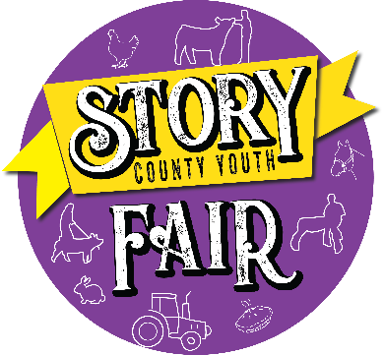
Story County Fair Association
P.O. Box 163
Nevada, IA 50201
515-290-9694 scfair85@gmail.com
Febru 2023

Dear Friends of the Story County Fair,
With 2022 having come to an end the Story County Fairboard has already started planning for 2023. The Fairboard works hard to provide an admission free fair for the residents of Story County and surrounding area. This gives our youth and their families a place for summer fun that is educational, entertaining and economical. The county fair showcases our youth reminding everyone of the talent, resources, products and cultural heritage that is abundant in Story County.
This year the Fairboard implemented a donation program called “Friends of the Fair” to help provide funds to organize events as well as manage and maintain the fairground facilities. The wide range of services we deliver are not always evident to the general public, but there is a great deal of activity that goes on at the fairgrounds year-round. The Fairboard has the responsibility to make important decisions for the long-term viability of the fairgrounds. The donation program created for the fairgrounds will help to continue to maintain and update the facilities for the annual Story County Fair. It also ensures that the facilities are available for other events held throughout the year.
Friends of the Fair sponsorship is a 3 year commitment with various levels of participation that you can choose from. The form explains these levels and what recognition is included at each level. The board wants to ensure that everyone is fully informed while making their donation decisions. You are welcome to call the fairgrounds office at 515-290-9694 with your questions. At no time will there be any pressure for you to donate.
We thank you for your consideration to be a part of this tax deductible Story County Fair sponsorship program. Sponsor participation is vital to continuing the tradition of excellence at the Story County Fair. It is our hope you will choose to be a part of this tradition.
Sincerely,
Amanda Johns
Fair and Operations Manager
2022 Fairboard
Wade Kahler, President
Eric Finch, Vice President
David Moody
Jodi Sterle
Mark Finch
Scott Smalley
Darren Toot
Kelly Sheets
Jessica Krupicka
Amanda Honnold
Derrick Black
Jo Mortvedt
Tyler Strathe

